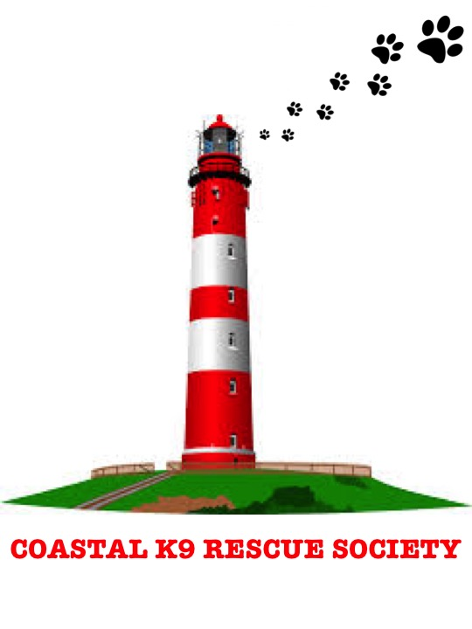
COASTAL K9 RECUE SOCIETY
1934 Marydale Road
St. Andrews, NS B0H 1X0

SURRENDER CONSENT
Name: ________________________________________________________________________________
Address: ________________________________________________________________________________
________________________________________________________________________________
Phone: ________________________________________________________________________________
Email: ________________________________________________________________________________
Description of Animal(s): ________________________________________________________________
_________________________________________________________________________________________________
Reason for surrender: ________________________________________________________________
_________________________________________________________________________________________________

I ______________________________ hereby relinquish ownership and any rights of the above-described animal(s) to Coastal K9 Rescue Society. I understand any treatment and appropriate placement of the above-described animal(s) will be at the discretion of Coastal K9 Rescue Society.

I certify I am the sole owner of the above-described animal(s). Dated this __________ day of ____________________, 20_____.

________________________________________ ________________________________________
Signature of Owner Witness

